Outland Haven
Game Design

Version 0.1
June 13, 2025

Rimvydas Medimas
Karolis Nagys
Dongseo University


Table of Content
Table of Contents
Table of Content 2
1. Introduction 4
1.1 Overview 4
2. Game Concept 5
2.1 Core Gameplay Mechanics and Dynamics: 5
2.2 Unique Features: 5
2.3 Inspiration and References: 5
3.Mechanics and Controls 6
3.1 Player Controls 6
3.2 Combat System 6
3.2.1. Player Capabilities (v0.1 Scope) 6
3.2.2. Weapon Tiers and Elemental Bows 7
3.2.3 Enemy Roles (Archetypes) 7
3.3 Economy 7
3.4 Loot and Inventory 9
Loot drives progression 9
Main Inventory (Safe Zone Storage) 9
Personal Stash (Limited, Active Storage) 9
4. Game World, Levels, and Environments 10
4.1 Flow Chart 10
4.1.1 Enemies 10
4.1.2 Danger zone 11
4.1.2 Danger zone 11
4.1.3 Town 11
4.1.3 Town 11
4.2 Progression 11
4.2.1 Player Progression 11
4.2.2 Character Leveling 11
4.2.3 Equipment Upgrades 11
4.2.4 The Progression Cycle 12
5. Story and Narrative 12
6. Visual Style and Assets 12
6.1 Visual Style and Art Direction 12
6.2 Concept Art and Design 13
6.3 Asset List (Minimal and Expandable) 13
6.4 Generative AI Tools Plan 15
7. User Interface (UI) and User Experience (UX) 15
7.1 In-Game Menu Layout and Design 15
7.2 HUD (Heads-Up Display) Elements 16
7.3 User Interaction and Feedback 16
7.4 Cut-Scenes and Narrative Presentation 16
8. Audio Design 17
9. Monetisation 17
10. Multiplayer Features 17
11. Testing and Quality Assurance 17
12. Marketing and Promotion 17
13. Project Timeline 17
Pre-Production & Planning (Months 1–2) 17
Production: Asset Creation & Core Gameplay (Months 3–6) 18
Alpha & Content Completion (Months 7–9) 18
14. Budget and Resources 18

1. Introduction
This Game Design Document outlines the vision for Outland Haven, a 2D isometric survival and resource management game developed as a bachelor’s final project. The game emphasizes mechanical design over visuals and explores the tension between safety and risk through a town-building and exploration loop. It is intended to showcase thoughtful game systems, progression, and meaningful player decisions.

1.1 Overview
Outland Haven is a single-player 2D isometric game where the player manages a small town as a safe haven while venturing into dangerous, resource-rich territories. The game blends resource gathering, crafting, and strategic upgrades with survival challenges and exploration.
The core gameplay loop involves building up the town, preparing expeditions, and taking calculated risks to obtain rare materials outside the safe zone — all while managing limited resources and permanent consequences.
- Target Audience: Indie gamers, fellow students, and players who enjoy system-driven gameplay focused on mechanics over visuals. Fans of survival, crafting, and exploration genres.
- Genre: Combat, Survival, Resource Management, Adventure, Light RPG.
- Theme: Risk vs. Safety, Isolation, Progress through Exploration.
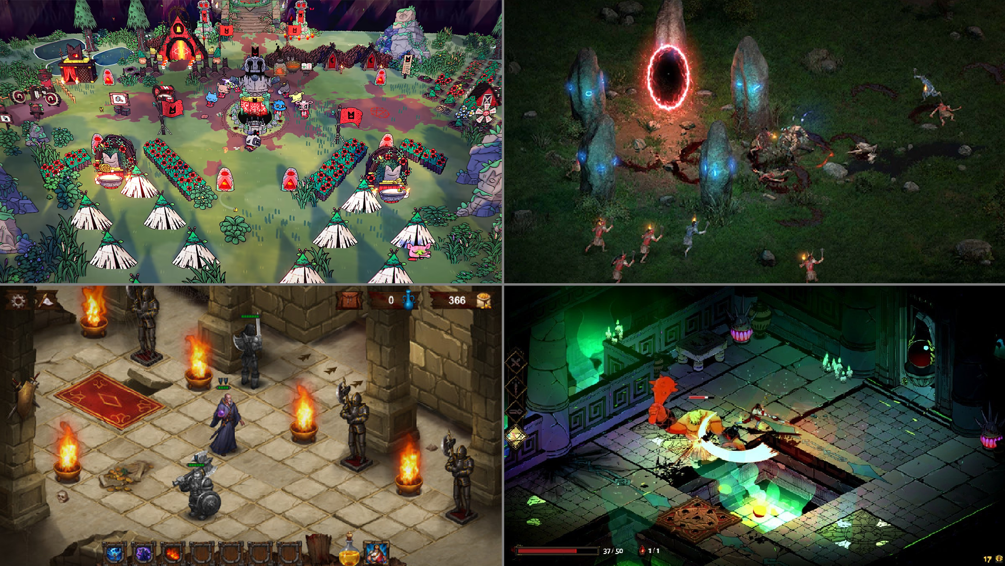
Some of the visual examples from other games
Cult of the Lamb
Diablo 2
Dark Quest 2
Hades

2. Game Concept
This is a 2D isometric game focused on combat, exploration, and upgrading. The player begins in a town, which acts as a safe area where they can craft, upgrade, and prepare for expeditions. To progress, the player must venture outside into hostile areas to gather resources, fight enemies, and return safely.
The core loop revolves around preparation in the town, exploration outside, and upgrading both the character and the town for better chances in future runs. The outside zones are manualy crafted and failure can mean the loss of some progress, adding tension to every expedition.

2.1 Core Gameplay Mechanics and Dynamics:
Resource gathering, crafting, and upgrades
Exploration-based combat and loot collection
Risk-reward loop (safe zone vs. dangerous area)
Character progression and town development
Light permadeath or punishment mechanics

2.2 Unique Features:
A dual-zone gameplay loop: safe hub and hostile wilds
Minimalist art style with focus on mechanical depth

2.3 Inspiration and References:
Minecraft – Resource gathering and crafting
Path of Exile 2 – Loot variety, enemies, and itemization
Rogue Legacy – Replayability and persistent upgrades
Darkest Dungeon – Planning, safe hub vs. danger zones

3.Mechanics and Controls

3.1 Player Controls
- Movement: 8-directional movement in an isometric view using the keyboard (WASD).

- Interaction/Action: Press E to interact with objects, pick up items, or activate context-sensitive actions.
- Combat:
  - Attack: Shoot an arrow towards the mouse position using the Left Mouse Button.
  - Dodge: Roll or dash in the current movement direction using the Space bar.

- Menu Access: Inventory (I), Map (M), Pause (Esc).

3.2 Combat System

3.2.1. Player Capabilities (v0.1 Scope)
The main character is designed as a Ranged-Only Combatant, relying on positioning and resource management.
  - Primary Action: Ranged Attack: The player's only offensive output is through their equipped bow and arrows. Melee combat or secondary weapons are explicitly out of scope for the initial prototype (v0.1).
  - Mobility Skill: Evasive Roll: The player can perform a quick roll for high-speed, short-distance movement. This action is the primary method for dodging enemy attacks and quickly adjusting positioning for optimal firing angles.
  - Implementation Note: The roll will grant a short window of invulnerability (i-frames). The Cooldown and Stamina Cost of the roll will be a key balancing factor.

3.2.2. Weapon Tiers and Elemental Bows
The character's versatility comes from the ability to wield various specialized bows, each introducing a unique projectile and combat pattern.
Regular Bow Offers the most reliable, consistent damage for sustained combat.
Electric Bow Arrows deal initial impact damage, then chain to a specified number of nearby enemies (e.g., 2-4 targets), dealing reduced secondary damage.
Fire Bow Arrows detonate on impact, dealing full damage to the primary target and splash damage to all units within a small surrounding radius.

3.2.3 Enemy Roles (Archetypes)
The danger zones will feature enemies categorized by their combat function and threat profile, forcing the archer to utilize their evasive roll and elemental arrows strategically.
Melee Closes distance quickly; forces the player to roll away. High burst damage at close range.
Ranged Maintains distance; forces the player to use line-of-sight and maneuverability. Consistent ranged chip damage.
Tank Slow, high Health and Defense; absorbs damage. Requires sustained high-damage to clear efficiently.
Fast Very high Movement Speed and Attack Speed; low Health. Designed to interrupt player's attack rhythm and punish stationary firing.

To manage scope and development time for the graduation project:
- Initial Design: The initial concept and behavior for each archetype (Melee, Ranged, Tank, Fast) will be defined during the Pre-Production and Prototyping phases.
- Progression Strategy: Throughout the game's progression (i.e., in later zones/levels), new variants of these base archetypes will be introduced primarily by adjusting their stats (Health, Damage, Speed) or by applying minor buffs (e.g., elemental resistance, temporary shields). This allows for quick content iteration without designing entirely new AI or combat patterns.

3.3 Economy
The game features four essential resources:
Food – too keep town alive, smith and gear enhancer require food to operate, produced by the farm.
Money – can be obtained from enemies, or by selling material to the smith, used to upgrade weapons and armour.
Material – gathered exclusively from enemies, material has a drop chance after enemy kill, used for gear maintenance or upgrades, can be sold for money.
Knowledge/XP – gathered from killing enemies, gained after killing certain amount of enemies. Used to upgrade a weapon or armor in town gear enhancer.

Farm
Produces food over time, requires tools crafted at the smith to function.

Stash
Stash is for storing resources and other items for further use. It is separate from players inventory, and can be accessed only in town. Space is unlimited.

Smith
Crafts and repairs weapons and gear, requires food to function, uses money and materials for crafting.

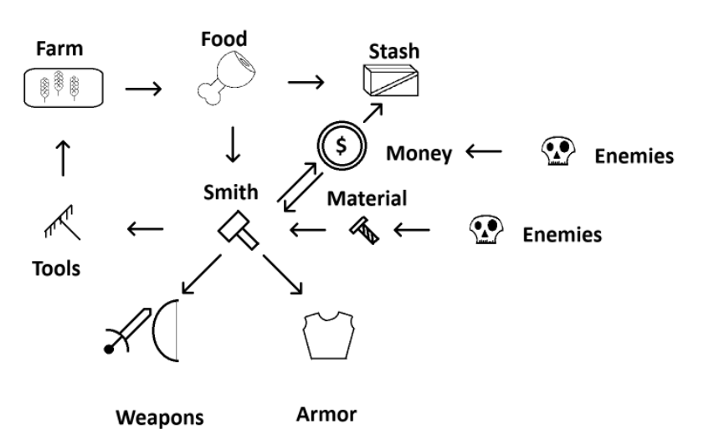
Gear enhancer
Enhancer can permanently upgrade weapon or gear stats like attack speed, damage, health etc. using XP, money and material, requires food to function.

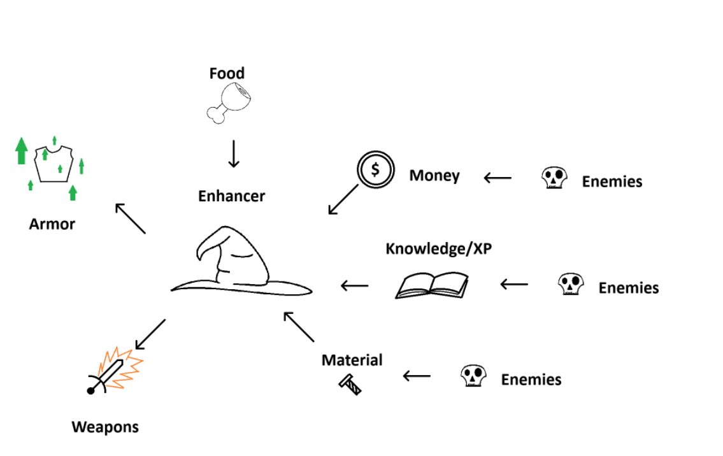
3.4 Loot and Inventory

Loot drives progression
Experience Points (XP), Materials, and Gold are the essential, automatically collected resources dropped by defeated enemies in Danger Zones. Item and equipment drops will be clearly visible and manually picked up.

Main Inventory (Safe Zone Storage)
The Main Inventory serves as the player's primary, large-capacity storage location for all equipment, items, and crafting resources. It is only accessible within safe zone and acts as the game's permanent resource repository.

Personal Stash (Limited, Active Storage)
Players are equipped with a limited-slot Personal Stash (e.g., 10 slots) for immediate item storage while actively exploring a Danger Zone. Items must be actively moved to the Main Inventory to free up Stash space.

4. Game World, Levels, and Environments

4.1 Flow Chart
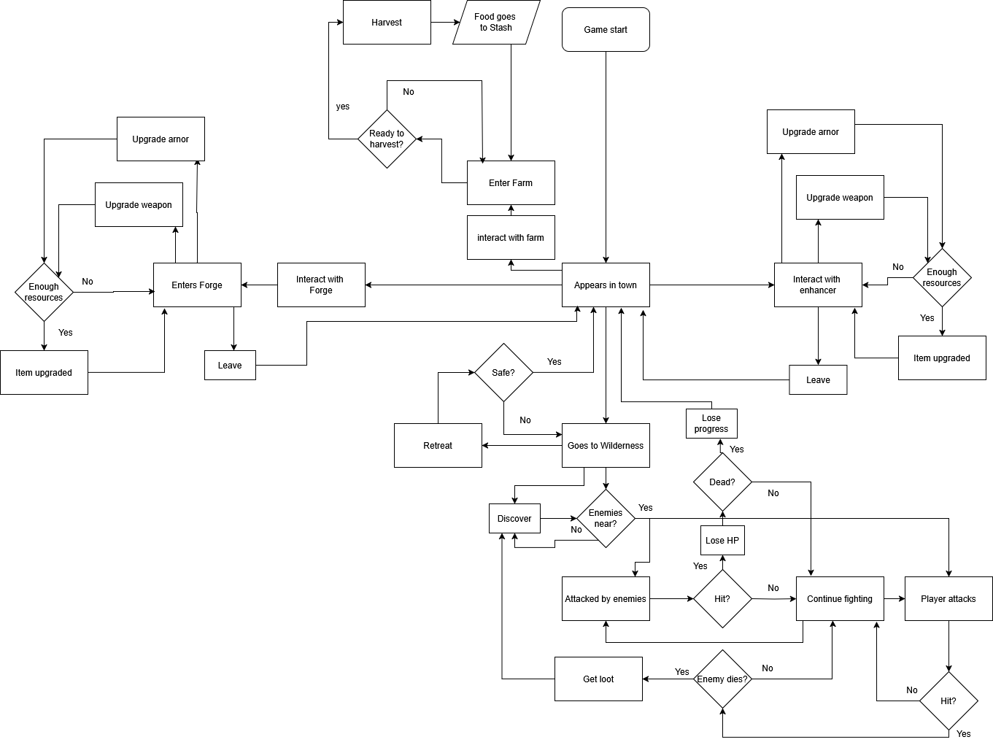

4.1.1 Enemies
Enemies exist exclusively within the Danger zone and are passive until the Player enters their Aggro Range. Once engaged, enemy behaviour is determined by type: Melee units close distance to strike, and Ranged units maintain distance to fire projectiles. All enemies are defeatable and will immediately despawn, dropping loot (currency or crafting materials) upon death.

4.1.2 Danger zone

4.1.2 Danger zone
The Danger Zone is a core combat and resource-gathering area, accessed by teleportation from the Town Hub. The primary loop is to enter, fight, collect loot, and safely return. This process is balanced by a high risk: death results in the loss of all inventory items, an immediate respawn in Town, and a percentage loss of gear durability. To maintain focus and prevent players from accumulating excessive resources in one session, the active inventory space is intentionally limited. This constraint encourages players to prioritize short, focused quests into different world areas, as each location offers distinct enemies and unique loot tables.

4.1.3 Town

4.1.3 Town
Serves as a safe hub where the player can store resources, upgrade or repair equipment, and manage the farm. The main Inventory, which provides unlimited storage space, is only accessible within the town. Players can interact with the smith to craft and repair gear using currency and materials, while the gear enhancer allows permanent stat upgrades using XP, money, and materials. The farm produces food, essential for keeping town services operational, and requires tools crafted at the smith to remain functional.

4.2 Progression

4.2.1 Player Progression
Player progression is built on two key pillars: leveling up the character and upgrading equipment. Both paths require players to gather resources and experience by fighting enemies in the Danger Zone and completing objectives. All progression activities happen in the safety of the Town.

4.2.2 Character Leveling
As players defeat enemies and complete quests, they earn Experience Points (XP). Gaining enough XP will level up the character, directly improving their core stats and making them more resilient and effective in combat.

4.2.3 Equipment Upgrades
Improving your gear is central to gaining power. Weapons and armor are upgraded as whole units through two different specialists in Town, each providing a distinct type of enhancement.
The Forger (Smith)
The Forger focuses on improving the fundamental stats of your equipment. By providing him with materials and currency, you can increase attributes like:
Raw Damage
Attack Speed
Armor Durability
To unlock more powerful upgrades, you must complete specific quests for the Forger, which may involve gathering rare materials or defeating tough enemies.
The Gear Enhancer
The Enhancer specializes in unlocking and improving the special abilities and skills of your weapons. By bringing him unique items, you can:
Add new skills to a weapon (e.g., a ricochet or piercing arrow).
Improve existing abilities (e.g., increase the power of a fire enchantment).

4.2.4 The Progression Cycle
The core gameplay is a loop: travel to the Danger Zone to gather materials and XP, return to Town to upgrade your character and equipment, and then tackle greater challenges. As players explore new areas in the Danger Zone, they will discover checkpoints that unlock fast travel, making future expeditions more efficient.

5. Story and Narrative
At this stage of development, the game’s narrative is intentionally left undeveloped to allow the story to evolve naturally as core game-play mechanics are established. The focus remains on designing and implementing robust systems and mechanics first, with narrative elements planned to be layered in later, depending on available time, resources, and design direction.

6. Visual Style and Assets

6.1 Visual Style and Art Direction
The game will use a minimalist pixel art style that focuses on clear readability over aesthetic complexity. The visuals will be functional representations of game states, designed to support gameplay clarity, not artistic expression.
- Perspective: 2D isometric projection
- Resolution: Low-res tiles and sprites (e.g., 32x32 or 64x64 pixels)
- Color palette: Limited palette with high contrast for visibility
- Animation: Minimal or single-frame animations where necessary (e.g., movement, interaction feedback)
- Priority: Clarity of mechanics and feedback loops over visual fidelity
This style supports the developer’s strengths in programming and system design while keeping asset creation and integration manageable for a solo developer.
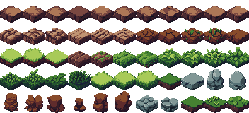

6.2 Concept Art and Design
The overall atmosphere blends a safe haven town with an ominous and mysterious wilderness. Visual contrast will help the player intuitively understand the risk level of their current area.
- Town: Bright, earthy tones, organized structures, calming layout
- Wilderness: Darker hues, chaotic shapes, ambiguous threats

6.3 Asset List (Minimal and Expandable)
The visual assets will be limited and modular to support rapid iteration and scalability. Below is the minimum viable asset list:
Characters
- Player sprite (idle, walk, attack)
- Basic enemy sprites

Some of the Enemy examples
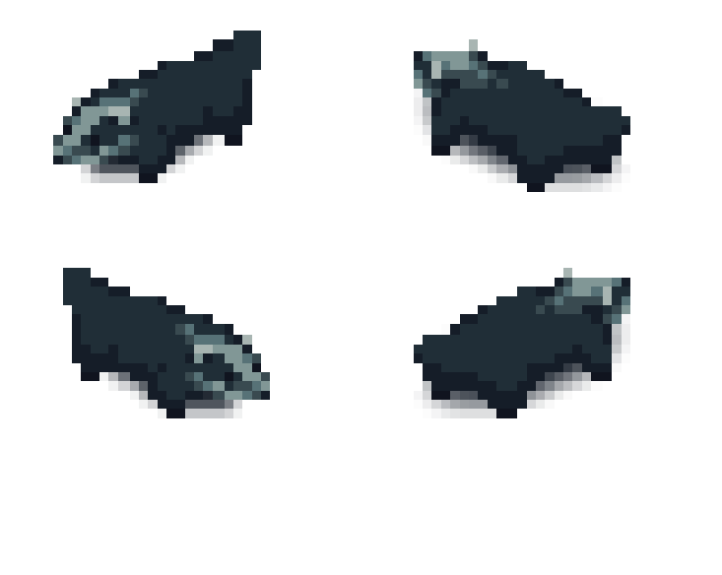
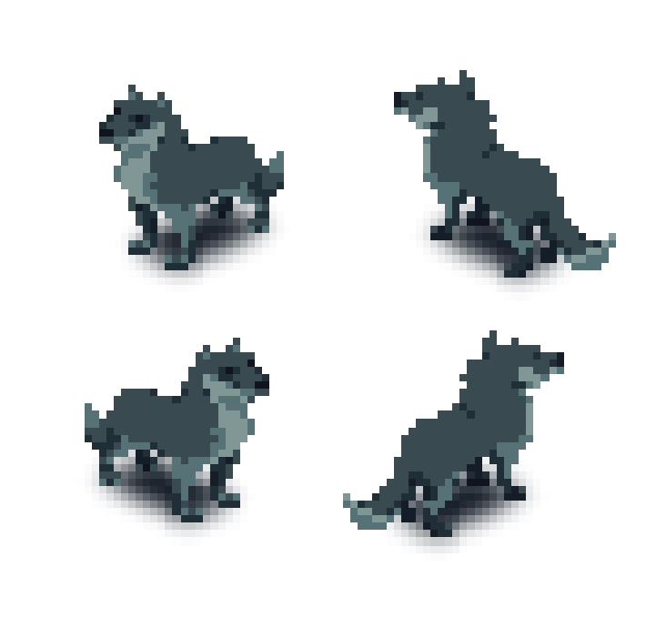
Environment
- Ground tiles (town, danger zones)
- Structures (houses, farm plot, forge, etc.)
- Nature elements (trees, rocks, water, etc.)

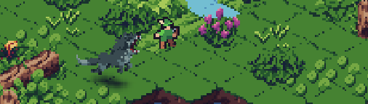

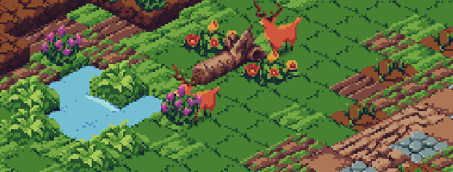
Objects & UI
- Collectibles (wood, stone, food, etc.)
- Crafting station icons
- Health/resource bars
- Simple inventory icons

6.4 Generative AI Tools Plan
AI-generated visuals (e.g., concept art, placeholder sprites) may be used in early development for:
- Mockups
- Visualizing game feel
- Presentation slides
Final in-game assets will be either original or from permissively licensed open-source pixel packs.

7. User Interface (UI) and User Experience (UX)

7.1 In-Game Menu Layout and Design
The user interface will be minimal and efficient, built around keyboard input.
Menus include:
- Main Menu – New Game, Continue, Settings, Exit
- Pause Menu – Resume, Save, Load, Exit to Menu
- Inventory/Crafting Screen – Grid-based, tabbed layout, showing:
  - Item slots (with icons, quantities)
  - Crafting recipes (selectable with feedback)
  - Equipment (player upgrades or tools)
Navigation will be based on arrow/WASD keys and confirm/cancel inputs (e.g., Enter, Esc).

7.2 HUD (Heads-Up Display) Elements
The HUD will display only the most essential information to avoid distracting the player:
- Health bar (bottom left)
- Inventory quick slots or tool belt (bottom)
- Resource counters (money, materials, etc.) with small icons
- Area indicator (e.g., “Town”, “Wilderness”) with subtle color-coded zone bar
The HUD adapts slightly depending on the area — for example, showing combat stats or threat levels when outside the town.

7.3 User Interaction and Feedback
Player input will follow a responsive and clean design:
- Keyboard WASD for movement, E for interact, I for inventory, etc.
- Mouse for aiming and shooting projectiles.
- Visual feedback for:
  - Successful collection or interaction (e.g., popup or color flash)
  - Errors (e.g., grayed-out button, sound cue)
  - Damage taken (screen flash or shake effect)
- Context-sensitive interactions: prompt when near objects or structures (e.g., “Press E to harvest”)

7.4 Cut-Scenes and Narrative Presentation
Since the project is solo and lightweight in art, cut-scenes will be minimal and primarily text/dialogue driven, with optional static illustrations or stylized screens.

8. Audio Design
Audio in the game serves a functional and atmospheric role, using simple, open-source sounds to reinforce player actions and establish a minimal yet immersive environment. The design avoids complexity, focusing on clarity and feedback rather than rich soundscapes.

9. Monetisation
The game will follow a fixed-price model with no in-game purchases or microtransactions.

10. Multiplayer Features
The game is a single-player experience with no multiplayer, networking, or co-op features planned.

11. Testing and Quality Assurance
The QA process will focus on building a stable and bug-free core gameplay loop, serving as a reliable foundation for future features and content updates. Initial testing will be done manually through frequent playtesting and iteration during development. Bugs will be tracked in a simple spreadsheet or issue tracker, categorized by severity and priority. The goal is to maintain a clean, stable canvas that ensures new systems can be added without introducing critical regressions or gameplay breaking issues.

12. Marketing and Promotion
The target audience includes indie game enthusiasts, fellow students, and players who enjoy adventure, combat, and resource management games with a focus on gameplay mechanics. Marketing will primarily rely on social media platforms, indie game forums, and student communities to build awareness. Key selling points are the deep gameplay systems, replayability, and a clear distinction between safe and combat zones, all wrapped in a simple, pixel-art style focused on mechanics rather than visuals.

13. Project Timeline
Starting 2025-09-01 ~ Finishing 2026-06-01. Approximately 9 Months

Pre-Production & Planning (Months 1–2)
This phase focuses on defining the core project vision, scope, and technical foundation. Key activities include finalizing the Game Design Document (GDD), establishing all core game math and systems, and creating initial placeholder assets for prototyping the fundamental gameplay loop (movement and combat).

Production: Asset Creation & Core Gameplay (Months 3–6)
This is the main development phase where the bulk of the game content is created and implemented. The focus shifts to integrating final art assets and animations, building all game levels and environment tilesets, and fully implementing the core RPG systems (inventory, leveling, equipment, and enemy AI).

Alpha & Content Completion (Months 7–9)
This final stage is dedicated to content completion, balancing, and preparing for release. The remaining story elements, final boss fights, and end-game systems are implemented, followed by extensive bug fixing through internal and external testing. The phase concludes with final polishing, optimization, and preparing the build for distribution.

14. Budget and Resources
Estimated Development Costs
As a solo student project, development relies primarily on free tools and open-source resources, minimizing financial costs. Main costs are related to time investment and potential optional assets.

Item Estimated Cost
Development Software (IDE, tools) Free (Visual Studio, Unity, etc.)
Art and Sound Assets Free/Open source
Personal Computer and Peripherals Already owned
Optional: Paid Assets or Tools ~€0–100 (if needed)

Resource Allocation
- Time: Solo development over 12 months.
- Personnel: One person (developer, designer, planner).
- Technology:
  - Programming: C#, Unity
  - Graphics: Simple pixel art (self-made or open-source)
  - Sound: Free libraries
  - Version Control: Git (GitHub)

